**TRADITIONAL APPROACH**

**ABSTRACT**

Coding Website is an application that provides an effective platform to learn C Programming and to analyze the skills and capabilities of each Individual.It is desgined toprovide convenience to the Users by including all the programming tools under one roof thereby avoiding the need to use multiple applications.This makes it easy for the Users to learn and test simultaneously as there is no need to download any external compiler or references.

This project is a complete website for the people with coding skills and the

ones eagerly waiting to learn coding. The users can learn basics about the language in which they will be coding and start writing their codes. These codes are compiled and run online and the user can easily get outputs and errors regarding the same. Learning is made easy and convenient by providing everything at one place

**INTRODUCTION**

Although numerous computer languages are used for writing computer applications, the computer programming language, C, is the most popular language worldwide. Everything from microcontrollers to operating systems is written in C since it’s very flexible and versatile, allowing maximum control with minimal commands.

The main perspective of the project is to make learning easy through various references and tests and provide all the learning tools at a single place.The aim of the project is to make all the programming concepts and terminologies clear thereby enabling the user to move on a fast learning track.The main objective is to teach programming in a simple way and also give the user a chance to analyze his own skills.

**PROPOSED SYSTEM ADVANTAGES OF CODING WEBSITE SYSTEM**

* The website will have an online compiler for the code without any need to download any compilers on your machine.
* Documentation of the language,code snippets and books downloading feature is available.
* Quizzes for testing the coding and language skills of the user.
* The user have to be registered for using all the above features.So a seperate login page using userid and password.
* Password forget option to recover your password by the user getting an email containing the same.
* Signup page for new users.
* The proposed system is user friendly because the retrieval and storing of data is fast and data is maintained efficiently.

**ANALYSIS**

**Feasibility Study:**

A Feasibility Analysis is a test of a system proposal according to its workability, ability to meet user needs and effective user resources. Feasibility study does not solve the problem, but it defines the scope of the work. During Feasibility study system analysis a report or documentation is prepared on the time and cost required for the development of the new system and also the benefits provided by the new system.

**Economic Feasibility:**

The purpose of the economic feasibility assessment is to determine the positive economic benefits.The system being developed at a basic level is cost efficient and logically possible to complete.

**Technical Feasibility:**

The technical requirement for the system is economic and it does not use any other additional Hardware and Software.

**Behavioral Feasibility:**

The system working is quite easy to use and learn due to its simple but attractive interface. User requires no special training for operating the system. Anyone having the general knowledge of operating the computer and the authority can operate the system.

**System Analysis:**

Systems analysis is the study of sets of interacting entities, including computer systems analysis. It is the process of studying a procedure or business in order to identify its goals and purposes and create systems and procedures that will achieve them in an efficient way. This field is closely related to requirements analysis or operations research. It is also an explicit formal inquiry carried out to help someone identify a better course of action and make a better decision than he might otherwise have made.

**Requirement Analysis**

Requirement Analysis in systems engineering and software engineering, encompasses those tasks that go into determining the need or conditions to meet for a new or altered product, taking account of the possibly conflicting requirements of the various users. It is an early stage in the more general activity of requirements engineering which encompasses all activities concerned with eliciting, analyzing, documenting, validating and managing software or system requirements. Requirement analysis is critical to the success of a systems or software project.

**DATA FLOW DIAGRAM:**

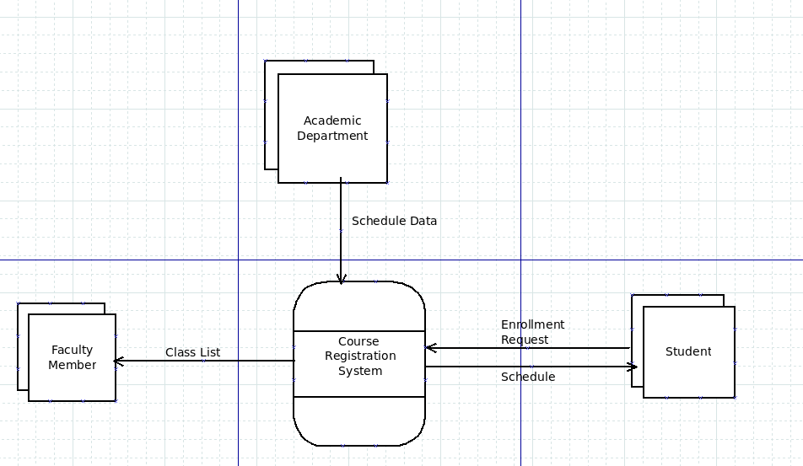

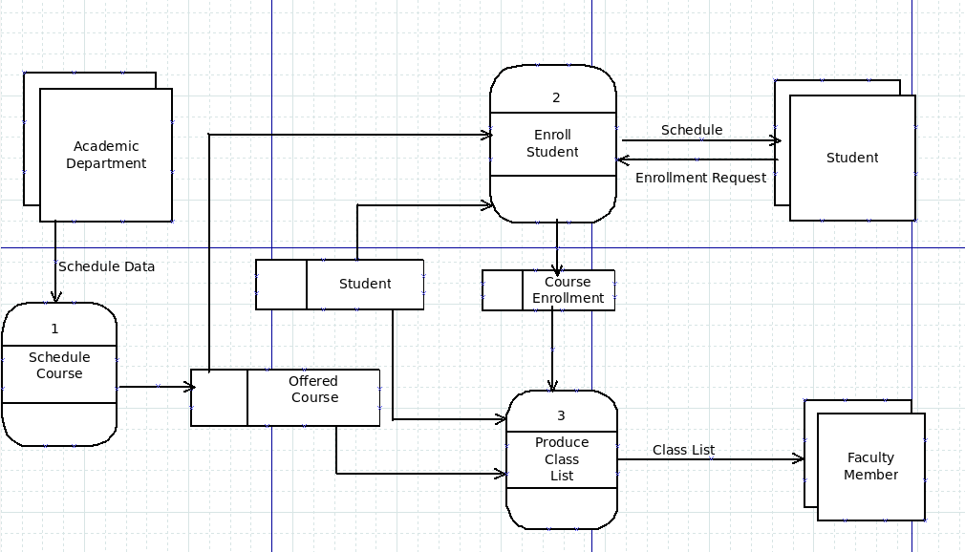

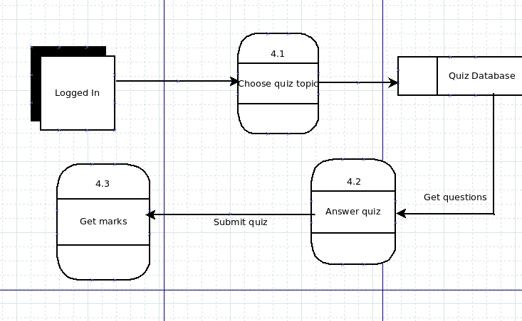

**DATA DICTIONARY:**

|  |  |  |  |  |  |
| --- | --- | --- | --- | --- | --- |
| **users** | | | | | |
| **P/F** | **Field Name** | **Data Type** | **Field Size** | **Constraint** | **Description** |
| P | id | integer | 10 | Auto Increment | Primary Key |
|  | fname | text |  | Not Null | First Name of the user |
|  | lname | text |  | Not Null | Last Name of the user |
|  | username | text |  | Not Null | Username of the user |
|  | emailid | text |  | Not Null | Email id of the user |
|  | password | text |  | Not Null | Password of the user |

|  |  |  |  |  |  |
| --- | --- | --- | --- | --- | --- |
| **users** | | | | | |
| **P/F** | **Field Name** | **Data Type** | **Field Size** | **Constraint** | **Description** |
| P | id | integer | 10 | Auto Increment | Primary Key |
|  | question | text |  | Not Null | Quiz questions |
|  | o1 | text |  | Not Null | Option 1 |
|  | o2 | text |  | Not Null | Option 2 |
|  | o3 | text |  | Not Null | Option 2 |
|  | o4 | text |  | Not Null | Option 2 |
|  | ans | text |  | Not Null | Answers to the questions |
|  | type | text |  | Not Null | Type |

**SYSTEM FLOWCHART:**

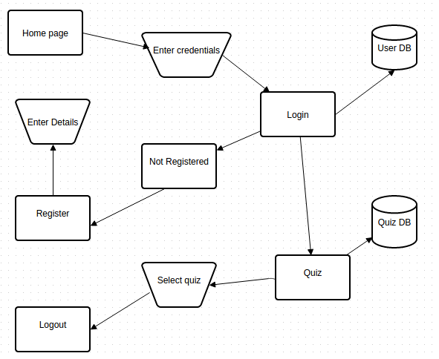

**STRUCTURE CHART:**

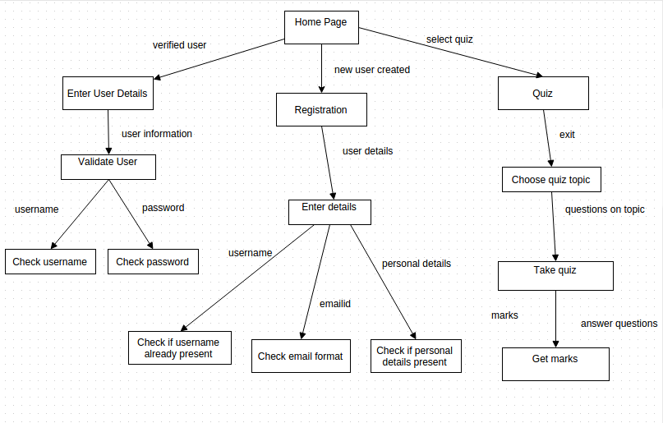

**MODULE PSEUDOCODE:**

If(new user logs in)

{

Register to the website

Enter your name

Enter username

Enter password

Enter other personal details

If(all the fields are filled and username is unique and length of password greater than 8)

User is registered

Go to Home Page

Else

Enter the details again

End If

}

Else

{

Go to Sign In page

Enter username and password

If(username and password matches in the database)

The user logs in to the system

Go to Home Page

If(quiz button is pressed)

Choose the topic of quiz to be taken

The questions of the same topic are displayed from database

Answer the questions

Click on submit

Check the answers

Result is displayed

End If

Else If(password forgotten)

Send email to the user about the password

End If

End If

}

End I

**OBJECT ORIENTED APPROACH**

**USE CASE SPECIFICATION:**

**TAKE QUIZ**

**Primary actors**: Registered User,System

**Preconditions**:

Network connection is active

Coding Website server is not down

**Basic flow of events**:

1. User logs on to the website.

2. User registers

3. User logs in

4. User is validated

5. User can go to the quiz page

6. User can choose the topic of quiz to be taken

7. System gives the questions of the topic from database

8. User can answer the questions

9. User clicks on the submit button after the quiz

10.System checks the questions and displays marks

**Alternative flows**:

2a. Customer enters username that already exists

2a.1 Customer is requested to enter another username

2b. Customer enters emailid that is not in proper format

2b.1 Customer is requested to enter another emailid

4a. Customer is not validated

4a.1 Customer is asked to log in again

**USECASE DIAGRAM:**

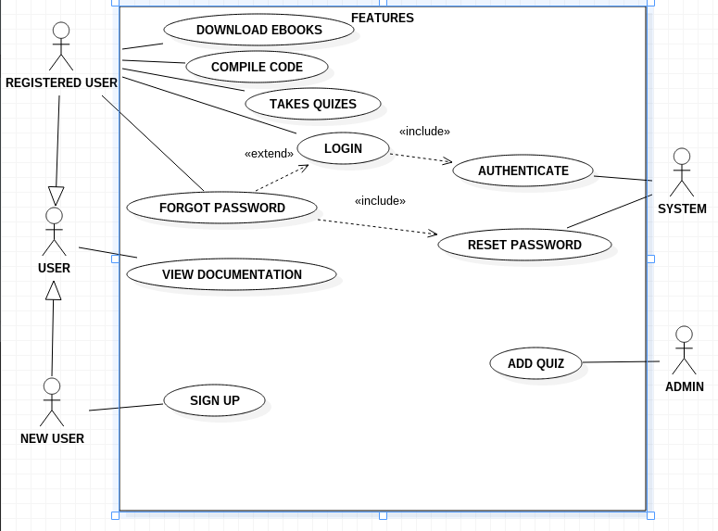

**FULLY DEVELOPED DESCRIPTION OF USE CASE:**

|  |  |
| --- | --- |
| Use Case Name : | DOWNLOAD EBOOKS |
| Scenario : | User wants to download the eBooks |
| Triggering Event : | User clicks on the Download eBook option |
| Brief Description : | When the User clicks on the download option the books gets downloaded |
| Actors : | Registered user |
| Related Use Cases : | None |
| Stakeholders : | User |
| Preconditions : | User must be logged in |
| Postconditions : | The number of downloads increase |
| Flow of Activities : | Click on the Download eBook option  Select the book you want to download  Click on the download button |
| Exception Conditions : | None |

|  |  |
| --- | --- |
| Use Case Name : | COMPILE CODE |
| Scenario : | User wants to compile the code |
| Triggering Event : | User clicks on the Compiler option |
| Brief Description : | When the User submits the code,the compiler compiles it and displays the output. |
| Actors : | Registered user |
| Related Use Cases : | None |
| Stakeholders : | User |
| Preconditions : | User must be logged in |
| Postconditions : | Appropriate output must be displayed |
| Flow of Activities : | Click on the Compiler option  Write the code in the text editor  Click on the Submit button |
| Exception Conditions : | None |

|  |  |
| --- | --- |
| Use Case Name : | TAKES QUIZ |
| Scenario : | User wants to take the quiz |
| Triggering Event : | User clicks on the Quiz option |
| Brief Description : | When the User clicks on the Quiz option,list of quizzes is displayed from which he can select the required quiz topic |
| Actors : | Registered user |
| Related Use Cases : | None |
| Stakeholders : | User |
| Preconditions : | User must be logged in |
| Postconditions : | Correct and Incorrect answers must be displayed |
| Flow of Activities : | Click on the Quiz option  Select the quiz you want to take  Mark the answers  Click on the Submit button |
| Exception Conditions : | None |

|  |  |
| --- | --- |
| Use Case Name : | LOGIN |
| Scenario : | User wants to log into the system |
| Triggering Event : | User clicks on the login option |
| Brief Description : | In order to enter into the system the user needs to enter his credentials |
| Actors : | Registered user |
| Related Use Cases : | Authenticate |
| Stakeholders : | User,System |
| Preconditions : | User must enter the details |
| Postconditions : | The details must be validated |
| Flow of Activities : | Click on the Login option  Enter username and password  Click on the Submit button |
| Exception Conditions : | None |

|  |  |
| --- | --- |
| Use Case Name : | COMPILE CODE |
| Scenario : | User wants to compile the code |
| Triggering Event : | User clicks on the compiler option |
| Brief Description : | When the User submits the code,the compiler compiles it and displays the output. |
| Actors : | Any user |
| Related Use Cases : | None |
| Stakeholders : | User |
| Preconditions : | User must be logged in |
| Postconditions : | Appropriate output must be displayed |
| Flow of Activities : | Click on the Compiler option  Write the code in the text editor  Click on the Submit button |
| Exception Conditions : | None |

|  |  |
| --- | --- |
| Use Case Name : | COMPILE CODE |
| Scenario : | User wants to compile the code |
| Triggering Event : | User clicks on the compiler option |
| Brief Description : | When the User submits the code,the compiler compiles it and displays the output. |
| Actors : | Any user |
| Related Use Cases : | None |
| Stakeholders : | User |
| Preconditions : | User must be logged in |
| Postconditions : | Appropriate output must be displayed |
| Flow of Activities : | Click on the Compiler option  Write the code in the text editor  Click on the Submit button |
| Exception Conditions : | None |

|  |  |
| --- | --- |
| Use Case Name : | COMPILE CODE |
| Scenario : | User wants to compile the code |
| Triggering Event : | User clicks on the compiler option |
| Brief Description : | When the User submits the code,the compiler compiles it and displays the output. |
| Actors : | Any user |
| Related Use Cases : | None |
| Stakeholders : | User |
| Preconditions : | User must be logged in |
| Postconditions : | Appropriate output must be displayed |
| Flow of Activities : | Click on the Compiler option  Write the code in the text editor  Click on the Submit button |
| Exception Conditions : | None |

|  |  |
| --- | --- |
| Use Case Name : | FORGOT PASSWORD |
| Scenario : | User has forgotten his password |
| Triggering Event : | User clicks on the Forgot password option |
| Brief Description : | When the User enters the credentials and they are validated,a mail is sent by the system containing the passoword |
| Actors : | Registered user |
| Related Use Cases : | Reset Password |
| Stakeholders : | User,System |
| Preconditions : | User must enter the username and email id |
| Postconditions : | Username and email id must be validated |
| Flow of Activities : | Click on the Forgot Password option  Enter the username and emailid  Click on the Submit button |
| Exception Conditions : | None |

|  |  |
| --- | --- |
| Use Case Name : | SIGN UP |
| Scenario : | User wants to register into the system |
| Triggering Event : | User clicks on the signup option |
| Brief Description : | When the User enters his personal details in the registration form,the details are validated and if correct then the user is added to the system |
| Actors : | Any user |
| Related Use Cases : | None |
| Stakeholders : | User |
| Preconditions : | User must enter the required details |
| Postconditions : | The details entered must be validated |
| Flow of Activities : | Click on the SignUp option  Enter the personal details  Click on the Submit button |
| Exception Conditions : | None |

|  |  |
| --- | --- |
| Use Case Name : | AUTHENTICATE |
| Scenario : | User details are validated |
| Triggering Event : | User submits the details |
| Brief Description : | When the User submits the details,they are validated |
| Actors : | System,user |
| Related Use Cases : | Login |
| Stakeholders : | System |
| Preconditions : | User must Enter the details |
| Postconditions : | The details entered must be validated |
| Flow of Activities : | Enter the personal details  Click on the Submit button |
| Exception Conditions : | None |

|  |  |
| --- | --- |
| Use Case Name : | RESET PASSWORD |
| Scenario : | User wants to reset the password |
| Triggering Event : | User selects the reset password option |
| Brief Description : | In order to reset the password,the user's identity must be validated and then only he can change the password |
| Actors : | System,User |
| Related Use Cases : | Forgot Password |
| Stakeholders : | User |
| Preconditions : | User must Enter the previous password |
| Postconditions : | The previous password must be validated |
| Flow of Activities : | Enter the previous password  Enter the new password  Click on the Submit button |
| Exception Conditions : | None |

|  |  |
| --- | --- |
| Use Case Name : | ADD QUIZ |
| Scenario : | Admin wants to add the Quiz |
| Triggering Event : | Admin selects Questions to be added |
| Brief Description : | Admin adds the quiz from the database |
| Actors : | Admin |
| Related Use Cases : | None |
| Stakeholders : | Admin |
| Preconditions : | Questions must exist in the database |
| Postconditions : | The questions must be displayed properly |
| Flow of Activities : | Admin selects the questions from the database  Admin add the questions |
| Exception Conditions : | None |

**ACTIVITY DIAGRAM:**

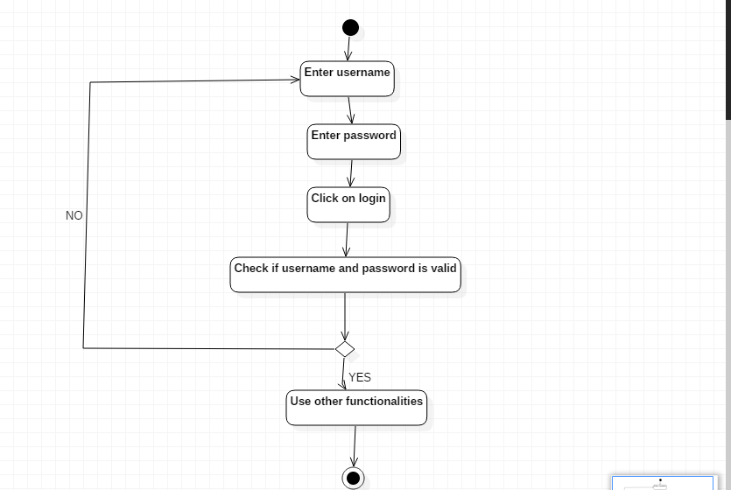

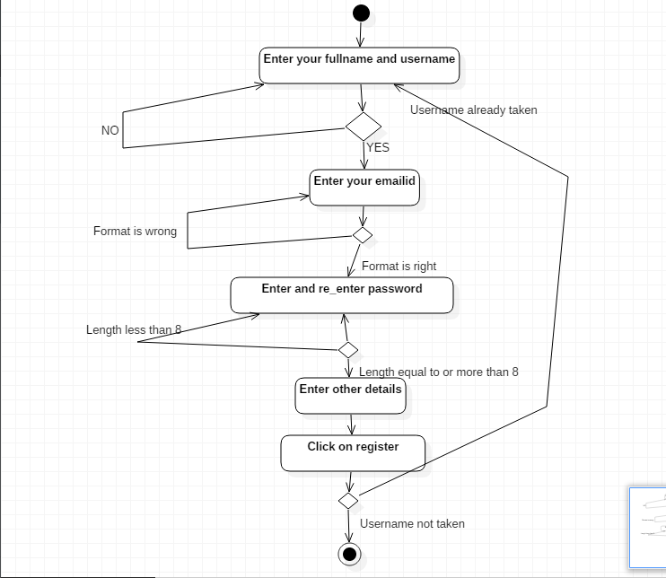

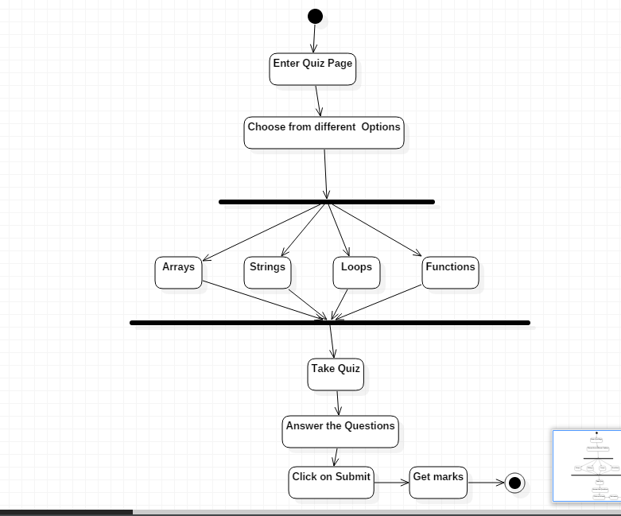

**CLASS DIAGRAM:**

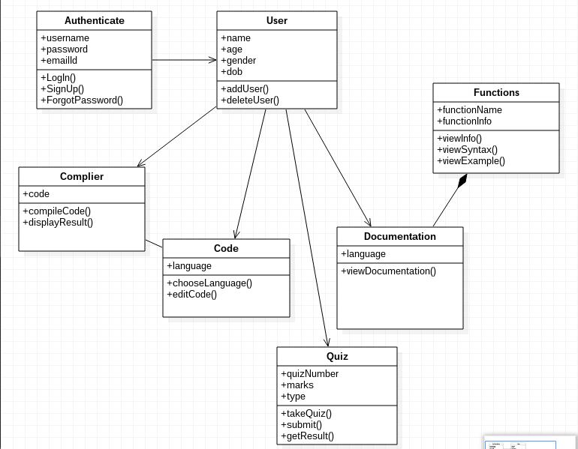

**SEQUENCE DIAGRAM:**

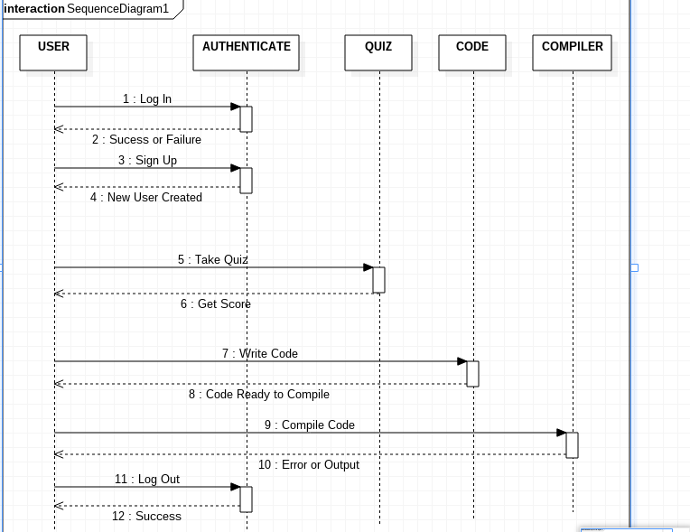

**STATE CHART DIAGRAM:**

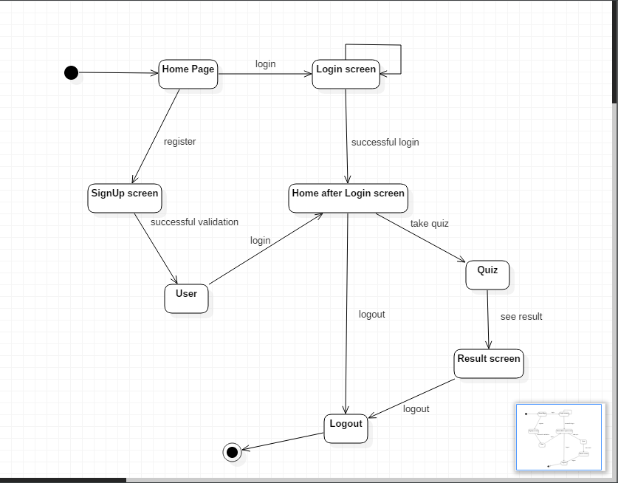

**MULTILAYER DIAGRAM:**

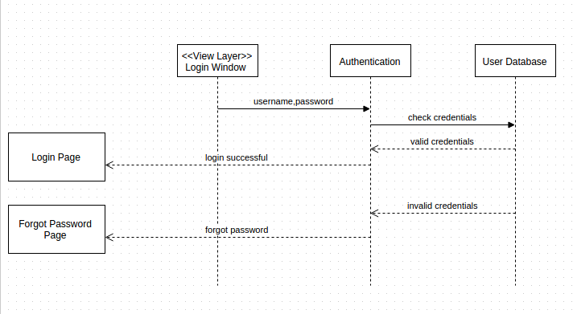

**PACKAGE DIAGRAM:**

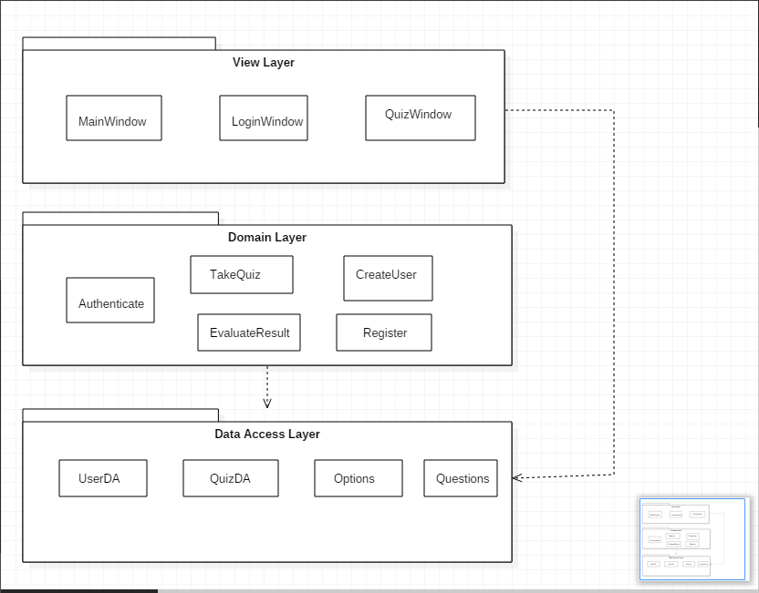

**COMPONENT DIAGRAM:**

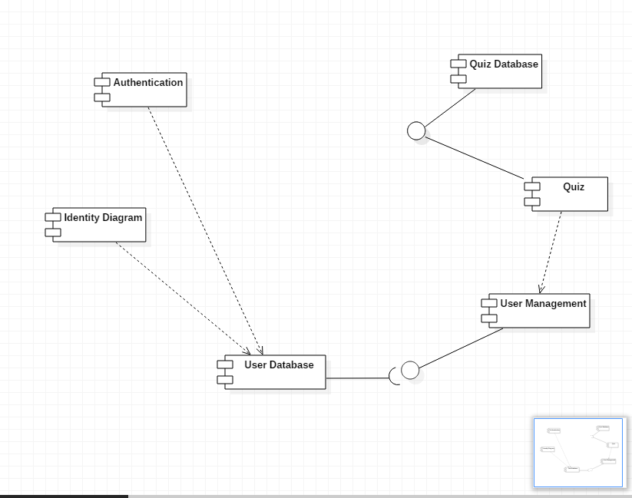

**DEPLOYMENT DIAGRAM:**

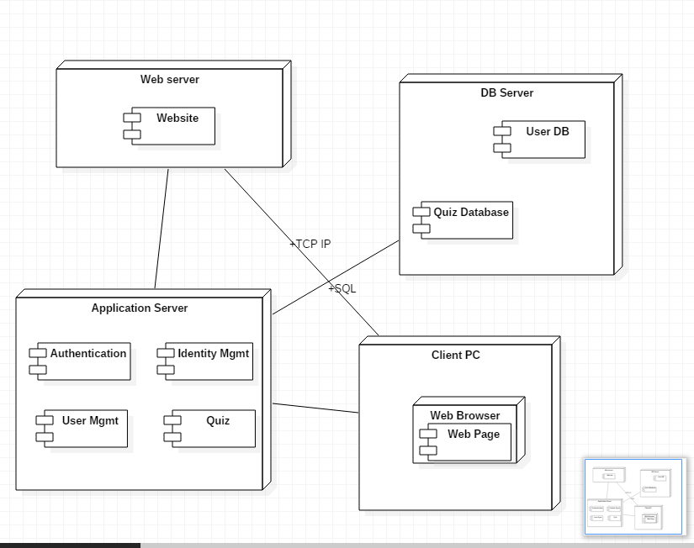

**PROJECT REQUIREMENTS**

**Software Requirements:**

* Operating System: Windows 10
* XAMPP Control Panel v3.2.1
* Apache Module v2.4.9 (Win 32)
* MySQL server version – 5.6.16
* phpMyAdmin version – 4.2.7

**Hardware Requirements:**

Peripheral Devices: Monitor, Keyboard, Mouse, Pen Drive, Printer

**APPLICATION PROTOTYPE**

**SCREENSHOTS OF THE APPLICATION:**

